**Assignment 1 solution:**

TASK1

1.

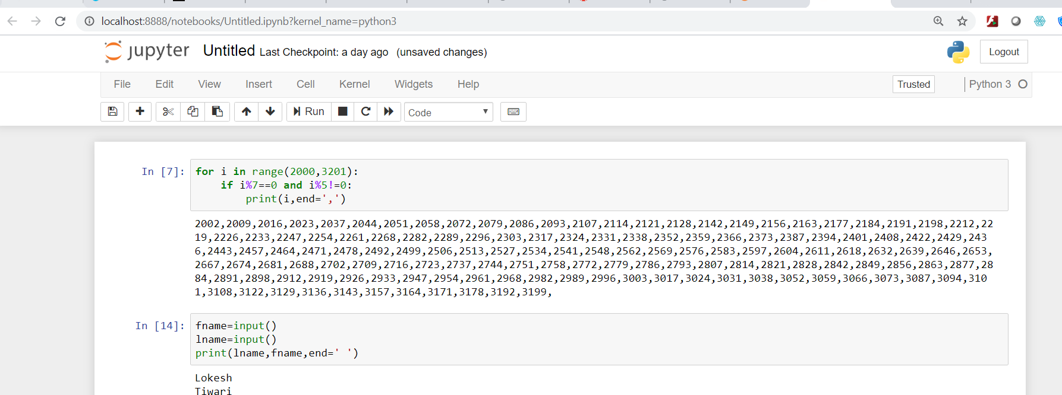

2.

for i in range(2000,3201):

if i%7==0 and i%5!=0:

print(i,end=',')

Output:

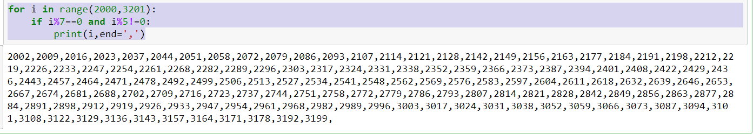

3.

fname=input()

lname=input()

print(lname,fname,end=' ')

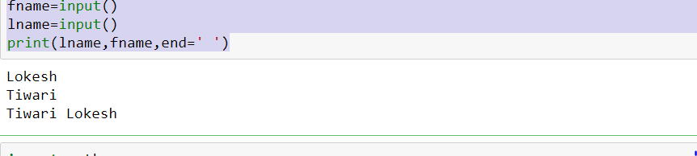

4.

import math

diameter=12

r=diameter/2

PI=math.pi

volume=(4/3)*PI*r**3

print(volume)

**Output:**

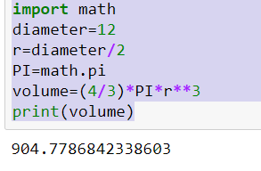

**TASK 2:**

**1.**

s=input()

l=s.split(',')

print(l)

Output:

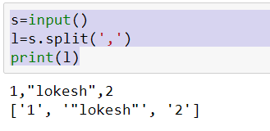

2.

for i in range(9):

for j in range(5):

if i<9/2 and j<=i:

print('*',end='')

elif i>=9/2 and i+j<9:

print('*',end='')

print()

Output:

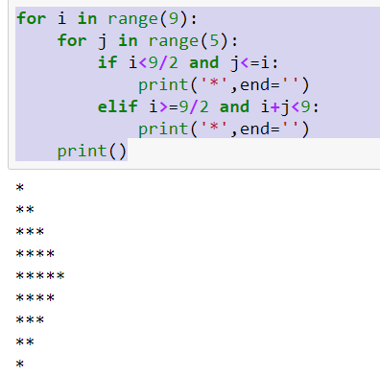

3.

s=input()

rev = s[::-1]

print(rev)

Output:

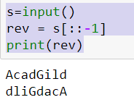

4.

print("WE, THE PEOPLE OF INDIA"+"\n"+"\t"+"having solemnly resolved to constitute India into a SOVEREIGN, !\n"+"\t\t"+

"SOCIALIST, SECULAR, DEMOCRATIC REPUBLIC\n"+"\t\t"+" and to secure to all its citizens")

Output

